Semiconductor Devices - Possible Questions

1 Sketch the circuit symbol for a photo diode.

2
a) Sketch and label a circuit diagram of a three phase full wave rectifier circuit supplied from a delta-delta connected supply transformer. Indicate load polarity.

b) Sketch the output waveform for one cycle of the circuit in (a).

c) A PTC thermistor has been fitted to provide thermal protection for the transformer in (a). Sketch a graph to show how the resistance changes with an increase in temperature.

d) If the output from the transformer in (a) was 400 V, 50 Hz, find the ripple frequency of the load voltage.

e) State TWO components that may be used as filters in rectifier circuits.

3 The figure below shows the circuit for an electronic speed controller, controlling a universal motor.
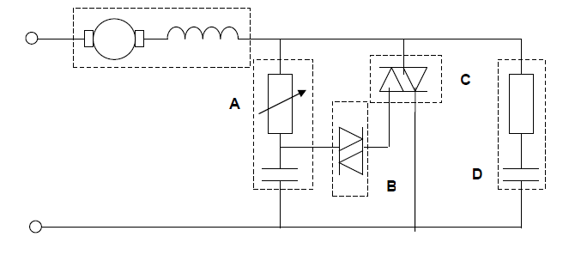

Name and describe the following components function

a)
i) A:

ii) B:

iii) C:

iv) D:

b) State the effect on the motor’s speed if the resistance of the variable resistor is increased.

c) Sketch graphs of time against current to show the:
i) input wave form.

ii) output wave form when the variable resistor is minimum

iii) output waveform when the variable resistor is half maximum

d) How could the direction of rotation of the series motor be changed?

4 State the names of the semiconductor devices that are used in a standard light dimmer to provide phase control.

5 The figure below shows a transistor being used to control a current operated load.
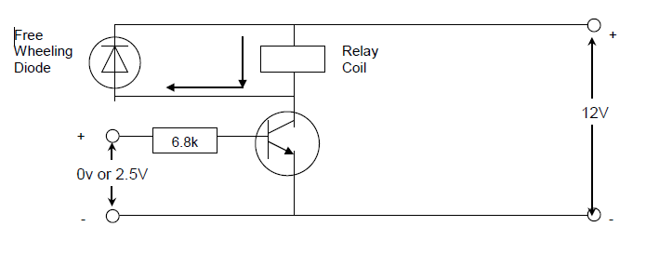

a) Describe the operation of the circuit:
In its off state.

In its on state.

b) State the transistor type, and explain the term saturation, with respect to its operation as a switch.

6 Sketch the drawing symbols for EACH of the following:

Diac

Zener diode

7 Name a device that can be used to protect semiconductor components against the effects of transient voltages.

8
a) Draw the circuit symbol for a voltage dependent resistor (VDR).

b) Explain:
i) the function of a VDR

ii) how a VDR carries out this function

iii) where a VDR is placed in a circuit

9 Sketch the circuit symbols for each of the following: (N01)

i) Triac

ii) NPN transistor

10
a)
i) Sketch and label a circuit diagram for a half-controlled, single-phase, full wave bridge rectifier supplying a resistive load.
Include in your diagram the following components;
• Single phase transformer.
• SCRs
• Diodes
• Load
• Control circuit (block only)

ii) Sketch the output waveform at half output.

b) State TWO components that may be used as part of a circuit to filter a rectifier output.

c) State TWO factors that will cause an SCR to be turned off once it has been triggered (turned on).

11 Sketch and label the circuit symbol for EACH of the following: (J01)

i) PNP bipolar junction transistor.

ii) A thermistor

12 What is meant by the term peak inverse voltage as applied to semiconductor devices?

13 List TWO common applications for a transistor.

14 Sketch the symbol for EACH of the following semiconductor devices: (N00)

i) Triac

ii) Light emitting diode

15 The circuit below shows a transistor that switches a light on at nightfall.
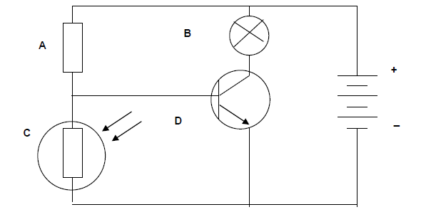

a) Identify each labelled component.

A
B
C
D

b) Describe how the circuit works during the day.

c) Describe how the circuit works during the night.

16 List TWO methods of dissipating the heat produced in a semiconductor device.

17
a) Sketch a circuit diagram of a single phase bridge rectifier supplying a resistive load. Show the polarity of the voltage across the load.

b) Sketch the input and output waveforms for the above circuit.

c) If the supply to the above circuit was 14 VAC what minimum peak inverse voltage (PIV) ratings would the diodes require?

d) Sketch simple circuit diagrams to show how an NPN bipolar junction transistor can be used as a :
i) common emitter amplifier.

ii) Switch controlling a lamp.

