Motor Calculations

Question 1
A 400V, 7.5kW, 50Hz, four pole induction motor has a slip of 5% when operating at full load.
(a) State the frequency of the motor currents at start.

50 Hz ______________________________________________________________________

(b) Calculate the frequency of the rotor currents at full load speed.

(c) If the motor has a power factor of 0.8 and draws a full load current of 18A, calculate the efficiency of the motor at full load.

Question 2
A delta connected fully loaded induction motor draws 90A from a 400V supply when started direct online. Show by calculation the current at start up that the motor would draw when connected to a star delta starter in the star position.

Question 3
State the formula for calculating the torque of a motor from its power and speed ratings.

Question 4
An engineering workshop has its own motor generator set producing three phase AC for their high speed angle grinders, which are fitted with squirrel cage induction motors. The prime mover is a four pole induction motor running at 6% slip, and the alternator has 36 poles per phase.
Calculate the alternator output frequency.

Question 5
(a) Calculate the full load line current for a 15kW, 400V, three phase induction motor with an efficiency of 87% and a power factor of 0.8 lagging.

(b) For the motor in (a):
i. Sketch the power triangle.

ii. Calculate the kVAr of the circuit.

iii. Calculate the kVAr of the capacitor used to improve the power factor to 0.95 lagging.

Question 6
A three phase motor has the following details on the nameplate:
• Volts 230/400
• Amps 40/23
• PF 0.7
• KW 10
(a) How should the motor windings be connected if the supply is 400V three phase?

(b) What full load current would be drawn by the motor with the connection in (a)?

(c) Explain the significance of each of the following:

i. PF 0.7

ii. KW 10

(d) Calculate the efficiency of the motor at full load.

(e) Explain why this motor would not be suitable for connection to a star delta starter.

Question 7
A 400V, 50Hz, three phase star connected alternator supplies a delta connected four pole induction motor that has a full load efficiency of 87% and a power factor of 0.8. The motor is rated at 14920W.
(a) Calculate the current in each motor winding.

(b) Calculate the current in each alternator winding.

(c) Calculate the speed of the motor if it has 3% slip.

Question 8
A three phase 6kW induction motor connected to a 400V, 50Hz, three phase supply has a power factor of 0.75 and an efficiency of 80% when fully loaded.
(a) Calculate the input power.

(b) Calculate the input kVA.

(c) Calculate the input kVAr.

(d) Calculate the phase angle.

(e) Calculate the line current.

(f) Sketch and label a power triangle for this circuit.

Question 9
An electric motor has a nameplate as shown below:
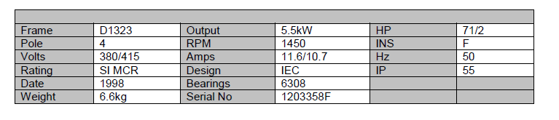

(a) Calculate the power factor of the motor with an efficiency of 85% when supplying full load and connected to a 415V supply

(b) What is signified by the letters IP and the numerals 55 (IP55) on the nameplate.

(c) Calculate the percentage slip speed of the motor at full load.

Question 10
An electric motor has a nameplate as shown below:
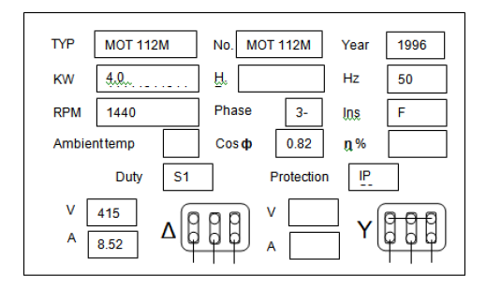

(a) Calculate the motor efficiency.

(b) Calculate the percentage slip at full load

Question 11
A three phase 4 pole motor has the following details on the characteristics:
• Supply Frequency 50Hz
• Line Voltage 400V
• Line Current 85A
• Efficiency 85%
• Slip 4%
• Line current lags voltage by 35°

(a) Calculate the rotor speed of the motor.

(b) Calculate the power factor of the motor

(c) Calculate the output power of the motor

12. A three-phase, 8 kW induction motor connected to a 400 V, 50 Hz, three-phase supply has a power factor of 0.81 and an efficiency of 84% when fully loaded. (ET21)
Calculate:
- The input power
- The input kVA
- The line current

(iv) State ONE reason why reduced-voltage starting of a large three-phase induction motor may be required.

