Lighting

1 Explain each of the following faults in a switch-start fluorescent fitting: (N03)

a) The tube does not strike and ends are glowing.

b) The tube attempts to strike but fails to maintain conduction.

c) The tube ends are blackened and the light outputs is low.

d) What would be the effect on the operation of a discharge lamp if the ballast short-circuited while working.

e) If the capacitor across a starter of a fluorescent light fitting short circuits, what effect does this have on the operation of the lamp.

f) Explain why single tube fluorescent fittings should not be installed in a machine shop?

2 State a typical application for each of the following lamps and give a reason for your choice.(J03)

a) Sodium Vapour (Low Pressure)

b) Metal halide.

c) List FOUR essential requirements for good lighting

d) State TWO precautions that must be taken when handling and installing linear type halogen lamps.

3 The owner of a hairdressing salon needs advice about replacing all of the old (cool fluorescent tubes in the salon. Ignoring cost, state the predominant consideration when recommending replacement tubes. (N02)
Give the reason for your answer.

4
a) The figure below shows a High pressure mercury vapour lamp. Label the lamp appropriately using number from the list provided. (J02)

(1) Internally phosphor-coated outer jacket
(2) Main electrodes
(3) Secondary electrodes
(4) Arc (discharge) tube

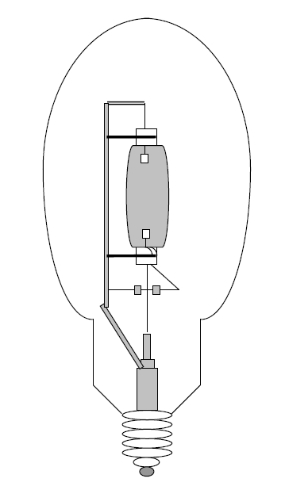

b) If discharge lighting that has been on for some time loses power momentarily (eg switched off and then on again) it take several minutes for the lamps to strike.
Briefly explain the reason for this.

5 Described below are situations that relate to the operation of gas discharge lamps and their control circuits. (N02)
Clearly state one associated hazard for each of the situations below.
a) Use of a standard multimeter to measure output in high pressure sodium or multi-vapour lamp control circuits.

b) Breakage of low-pressure mercury vapour lamps (fluorescent tubes) either accidentally or during disposal.

c) Disposal of low and / or high-pressure sodium vapour lamps

d) The operation of an HID metal halide lamp with broken outer envelope.

6
a) Identify each of the components in the figure below and describe their function (or functions) in the circuit.

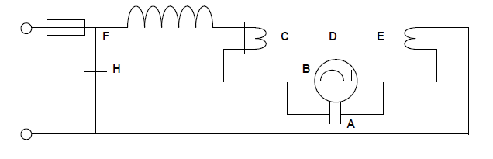
Component A:

Function:

Component B:

Function:

Component C & E:

Function:

Component D:

Function:

Component F:

Function:

Component G:

Function:

Component H:

Function:

b) Define the term luminous flux and state the letter symbol and unit.

7
a) List the four essential requirements for good illumination in lighting design.(

b) Explain why single-tube fluorescent fittings should not be installed in a machine shop.

c) State a typical application for each of the following lamps and give a reason for your choice.

i) Sodium vapour

Application:
Reason:

ii) Metal halide

Application:
Reason:

iii) Fluorescent

Application:
Reason:

8
- Sketch and label the circuit diagram of a single-tube, switch start fluorescent light.

b) Describe the operation of the circuit in (a)

c) Explain the cause of each of the following faults in a switch start fluorescent fitting:
i) Tube does not strike and ends are glowing

ii) Tube attempts to strike but fails to maintain conduction

iii) Tube ends are blackened and light output is low

9 State two ways of reducing the stroboscopic effect caused by discharge lighting.

10 What is the definition for a luminary?

11 What is the definition for luminous intensity?

12 Name four requirements for good illumination.

13 What is luminous efficacy?

14 What type of meter is used to measure illuminance?

15 Name four factors that will affect the life of an incandescent lamp.

16 What does the Ra of a lamp mean?

