**Chapter 7.** from **NORSOK\*** STANDARD Common requirements **MECHANICAL COMPLETION AND COMMISSIONING** <http://www.standard.no/pagefiles/963/z-cr-007r1.pdf>

**\*NORSOK** ('Norsk Sokkels Konkuranseposisjon') are standards developed by the **Norwegian Technology Centre**.

**7 COMMISSIONING**

**7.1 Introduction**

This basis for preparation and execution of commissioning which takes place when Mechanical completion is completed for a system or part of a system. It consists of three main activities:

• Commissioning preparation

• Commissioning execution

• Commissioning documentation and handover to operation

Establish a commissioning network and define commissioning packages early in a Project in order to establish fabrication/installation priorities and milestones.

Definition of commissioning of part systems is essential in order to achieve an early commissioning completion.

**7.2 Typical commissioning preparation activities** consist of:

• Development of commissioning organisation

• Development of system breakdown (part system)

• Commissioning packages definition

• Commissioning schedules

• Commissioning budget including spare parts for commissioning

• Commissioning preparation check record

**7.3 Commissioning procedure content**

Commissioning shall be executed by guidance of a detailed procedure describing:

**7.3.1 Objective Details** the operating parameters to be achieved.

**7.3.2 Description** - a brief description of the system/part systems to be commissioned,

including marked up piping and Installation diagram [P&ID] as a basis for all functions

to be tested.

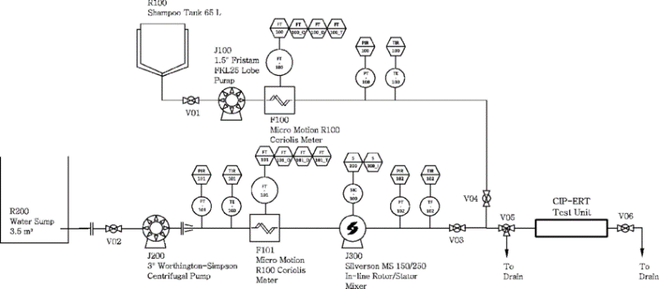←An example of a P&ID

**7.3.3** **Temporary equipment and consumables** - list all consumables, temporary

equipment, tools, and requirements for suppliers’ assistance.

**7.3.4** **Health/Environment/Safety -** list of all toxic and polluting fluids and materials

describing their handling and disposal. Also a check list of all required safety

precautions including requirements for work permit.

Prior to energising electrical equipment issue a ‘livening up’ notice to inform all

involved parties of forthcoming energising.

**7.3.5** **Preservation requirements** - for removing existing preservatives/protection and

subsequent new preservation of the system if it will be out of operation for a period.

**7.3.6 Scope** - detail the work to be done step by step including the commissioning

preparation, check record. Log irregularities and faults. Incorporate equipment

suppliers’ start-up procedures in the documentation. Include performance parameters

to compare expected performance with actual result achieved during commissioning.

**7.3.7 Planning** – calculate detailed commissioning plans for system/part system including

operative hours per discipline and supplier assistance hours.

**7.3.8 Handover** - shall contain a certificate and other documents agreed with operation.

**7.4 Commissioning documentation and handover to operation**

Handover of systems from Executor to project/operation shall be according to a formal procedure which as a minimum should consist of:

• Completion acceptance certificate (signed by both parties)

• Commissioning P&ID showing the extent of the completed system

• Authority certificates (if any)

• Operational procedures and handbooks.