**Motors and Starters – Possible Questions**

1 List two reasons why a shaded pole motor is used to power the fan in a portable heater.

2 Why is a three phase induction motor more efficient than the equivalent size single phase induction motor?

3 Give an application where a three phase motor would require phase reversal protection.

4 State TWO reasons for using reduced voltage starting for a three phase induction motor.

5 What is the purpose of maintaining contacts in a direct on line reversing starter?

6 Explain the effect that a reduction in supply voltage will have on the line currents of a loaded three phase induction motor.

7 What is the cheapest type of reduced voltage starter for three phase motors, and what special requirement, if any, does this method of starting impose on the internal connections of the motor windings?

8 State ONE important reason for inserting external resistance into the rotor circuit of a slip ring motor at start up.

9 What is the main advantage of a single phase synchronous motor over other single phase motors?

10 Sketch a torque speed graph for a three phase squirrel cage induction motor. On the graph show:

• Starting torque

• Pull out torque

• Full load torque

• Synchronous speed

• Full load speed.

11 A primary resistance starter reduces the motor terminal voltage during starting by inserting resistance into each supply line. The motor terminal voltage ramps smoothly up during acceleration as a function of the decreasing line current and voltage drop across the line resistances. (J02)

Explain, in principle, how an electronic ‘soft starter’ achieves the same thing

12 What type of three phase ac motor is most likely to have a wound rotor and an external resistance bank?

13 Give FOUR reasons why universal motors are more suitable than single phase induction motors for use in portable power tools.

14 Give a reason why reduced voltage starting of a three phase induction motor may be required.

15 What effect does a drop in supply voltage have on the supply current to a fully loaded, three phase, squirrel cage induction motor?

16 List TWO advantages a capacitor-start, capacitor-run motor has over a resistance-start, split-phase induction motor.

17 List TWO types of protection afforded by a direct on line starter and overload supplying a three phase motor.

18 List THREE types of reduced voltage starters (excluding electronics) that can be used with a three phase squirrel cage induction motor.

19 Give TWO reasons other than cost why a universal motor is used for portable tools.

20 The thermal protection device in a three phase motor starter is primarily designed to disconnect the motor on the occurrence of what type of fault.

21Sketch a typical current and torque curve for a DOL starter

22 Sketch the current/torque curve for a star/delta connected motor.

23. Give short descriptive answers to explain the following terms:

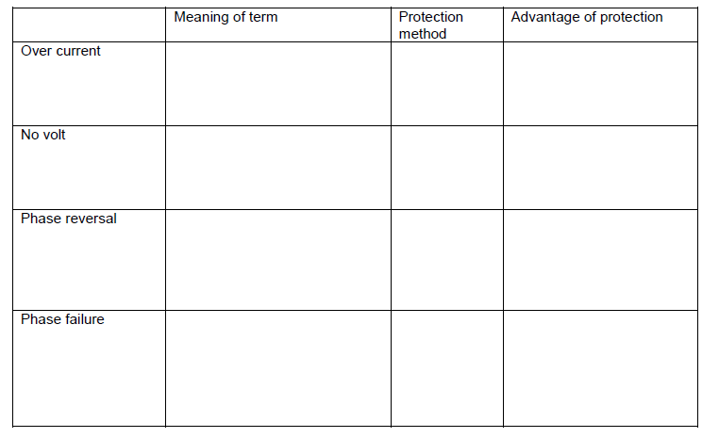

24. When using a AC Speed drive harmonics are being generated. Why must it be kept at a minimum

25. When AC motors run at lower than rated speeds what precautions must be taken and why.

26. Complete the following table on motor starters.

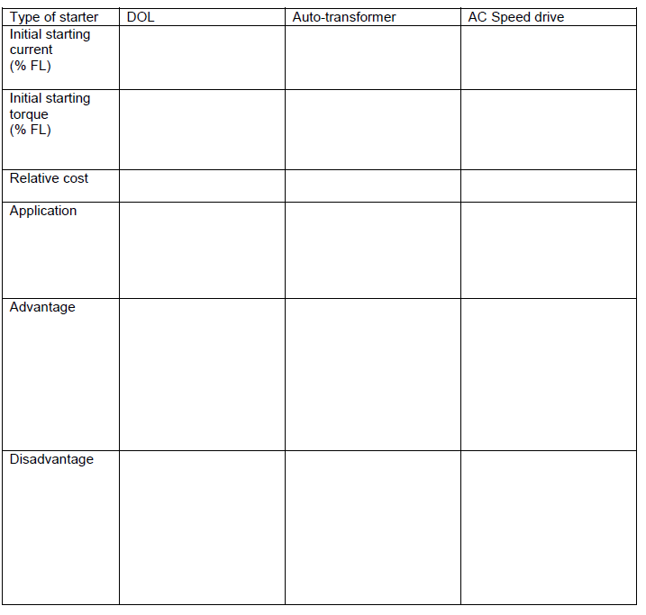

27. Give a typical application for the following starters and give a reason why you have chosen that application

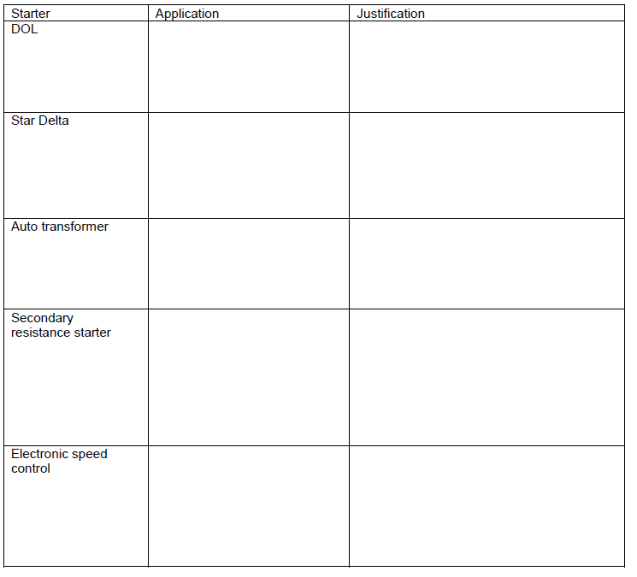

28. (a) A three-phase induction motor is started by a star-delta starter

(i) State the percentage of the direct-on-Line starting torque in the start (star) position.

(ii) State two forms of protection’ incorporated in the starter’s circuitry.

(iii) Briefly explain the purpose of the interlocks.

(b) The same motor could be started by an auto-transformer starter.

(i) What would be the main advantage of this starter over the star-delta starter.

(ii) State which auto-transformer tapping should be chosen first, and give the reason.

(iii) If the motor fails to start satisfactorily on the initial choice of tapping, what action should be taken and why.

29***.*** List THREE reasons for using reduced voltage starters with squirrel-cage induction motors when DOL may accelerate the load up to speed more quickly.

30. Sketch a circuit diagram of a single–phase, capacitor-start, induction-run motor.

31. Sketch the power circuit diagram of a resistance starter connected to the wound rotor windings of a slip-ring induction motor. (The control circuit is NOT required).

b. Explain what special requirements are needed when slip-ring motor controllers are used for speed

control.

c. Give TWO applications of a slip-ring motor with starter, and reasons for their use.

32. A three-phase motor has windings rated at 230V and is to be connected in Star to a 400V three-phase supply. How many terminals must there be on the terminal block?

33. How is the direction of rotation reversed in a delta-connected, three- phase, squirrel-cage motor?

34. How is the direction of rotation reversed in a single-phase, split-phase induction motor?

35.

(a) State THREE technical advantages that electronic starters have over electro-mechanical starters

(for example, an auto-transformer starter).

(b) A three-phase induction motor is started by a star/delta starter. State TWO reasons why interlocks are

used in the starter.

(c) A three-phase induction motor is started by an auto-transformer starter.

1. What would be the main advantage of this starter over a star/delta starter?
2. (ii) The auto-transformer has tappings of 40%, 60% and 80%. State the reason why the 40% tapping should be chosen first.
3. If the motor fails to start satisfactorily on the 40% tapping, what action should be taken and why?

36. (a)Draw and label a circuit diagram of a 230V control circuit for a three-phase DOL motor starter. Only the

items listed below are to be included.

• The polarity.

• A fuse that protects the entire circuit.

• A stop button that controls the circuit.

• A start button that controls the circuit.

• A hold in contact (maintaining contact).

• A thermal overload relay contact.

• A 230V coil.

(b) Redraw the stop and start buttons you have drawn in (a) above and show how a remote stop-start station may be connected into the circuit by the use of a three-core cable.

(c) State one other type of protective device that could be used in place of a thermal overload.

37. (a) Describe the method by which a single-phase supply may be used to simulate a rotating magnetic field

effect for a split-phase single phase induction motor.

(b) If an external starting relay is to be used to for a single-phase, split-phase induction motor, which winding

will it switch?

(c) In a single-phase, capacitor start induction motor, what would be the effect on the performance of the motor

if the run winding was open-circuited:

1. And the motor was switched on whilst on load?
2. While the motor was running whilst on load?

38. You have been requested to wire a DOL forward and reverse starter that controls a three-phase delta connected motor. (ET26)

1. Draw and label the power circuit for the DOL starter. The drawing must show the contactors and conductors that enables the motor to be operated in the forward and reverse directions.
2. Draw and label the 230V control circuit for the DOL forward and reverse starter.

39. (a) You have been requested to wire an automatic star/delta starter for a 15kW motor in a workshop. The motor starts in star and runs in delta. (ET28)

Draw and label the power circuit for the automatic star/delta starter showing all components necessary to make it work correctly and safely.

(b) You have been requested to wire an automatic Star/Delta starter for a 15kW motor in a workshop. The

motor starts in Star and runs in Delta.

Draw and label the 230V control circuit for the automatic star/delta starter showing all the components to

enable it to run correctly and safely.

40. (a) A three-phase squirrel cage induction motor is running on full-load. It is controlled by a DOL starter.

(i) A small mechanical overload over a long period of time has occurred. What effect does this fault have

on:

(ii) A mechanical overload has occurred that caused the motor to exceed it pull-out torque (break-down torque).

What effect does this fault have on:

• The motor

• The motor protection.

(b) A three-phase squirrel cage induction motor is running on full-load. It is controlled by a DOL starter.

(i) Under-voltage has occurred on the supply to the motor and starter. What effect does this fault have on:

The motor

The motor protection.

(ii) An open circuit has occurred in one winding of the motor. What effect does this fault have on:

• The motor

The motor protection.

(c) Describe how the reduction in speed of a three-phase induction motor caused by an increase in mechanical

load causes an increase in line current.