Circuit Protection - Possible Questions

1 State the TWO types of operation employed by most circuit breakers

2 Why is it important that an RCD is tripped before each use?

3 How many earthing conductors does a monitored earth circuit require?

4 Give an application where a three phase motor would require phase reversal protection?

5 The figure below represents 3 fluorescent lights supplied from a 230V MEN supply. The circuit is   
protected by a 16A, 6kA circuit breaker at the switchboard. Each fluorescent fitting is protected by a 1A   
glass cartridge fuse. (J03)

1. If a voltmeter were connected across the terminals of the circuit breaker what voltage would it read   
   when:   
     
   i. the light switch and circuit breaker are both closed?

ii. The light switch is closed, but the circuit breaker is open?

1. Explain how back up protection is provided in the circuit in Fig1.
2. List TWO reasons why the glass cartridge fuses in the fluorescent fittings must not be shorted out or   
   increased in current rating.
3. What is meant by discrimination as applied to circuit protection and how is discrimination achieved in   
   Fig1.

6 A three phase star connected pottery kiln draws 20A from a 400V supply and is protected by 32A fuses. A fault of 8 ohms has developed between one line and the kiln frame while the kiln is operating. Assume that the protective earth conductor resistance is 0 ohms and the fuse has a fusing factor (gG Utilisation   
Category) of 1.5

a) Sketch and label a circuit diagram of the circuit.

b)

i) Calculate the total current in the faulty line.

ii) Determine by calculation and state the effect if any, that this fault will have on the circuit protection.

c) If the earth continuity conductor resistance to the kiln was 10 ohms and the same 8 ohms fault   
occurred between line and the kiln frame, explain with the aid of calculations, what electrical hazard   
this presents to the user.

8 An HRC fuse is labelled 80kA. Explain what this means.

9 There are a number of factors that limit the current at the fault location when a short circuit occurs in an   
electrical installation. List TWO of these factors.

10 A trolley mounted three phase pump is supplied from a monitored earth unit. With respect to either the   
wiring or the components used, list FOUR unique features of this form of protective device.

11 HRC motor rated fuse links are capable of very fast operation and are commonly used to provide back up protection for the thermal overloads in a DOL three phase motor starter.

1. Why do the thermal overloads need such protection when they are designed to trip out in response   
   to a sustained overcurrent drawn by the motor.
2. With respect to the thermal overload unit, explain briefly the difference between and possible   
   significance of a three phase trip and a single phase trip.

12 A three phase, 400V, 12kW star connected electric motor is operating at full load when a fault of 10 ohms occurs between Line 2 and the frame, which is earthed.

1. Sketch and label a circuit diagram of the circuit.
2. Calculate the power that is dissipated by this fault. (ignore the power taken by the motor, which continues to run)

13 A single phase, class 1 , plug in toaster has a 35 ohms fault between the phase conductor and the metal case, but is effectively earthed by the earth continuity conductor, which has a resistance of 0.1 ohms.   
Show by calculation, why there is insufficient voltage between the exposed metal case and earth to present an electric shock hazard.

14 State the maximum permitted operating time for an RCD used for personal protection on occurrence of an AC. fault, where the current imbalance is equal to or greater than five times the rated residual current.

15 A three phase, 400V, star connected lathe draws 20A from the supply and is protected by 32A motor rated fuses (gM @ 2.5). A fault of 12 ohms has occurred between line three and the machine frame while the machine was operating. Assume the earth continuity resistance is 0 ohms. (J02)

1. Sketch and label a circuit diagram of the circuit.
2. Calculate the total current in the faulty line.
3. Show by calculation the effect, if any, that this fault would have on the circuit protection.
4. If the earth continuity resistance to the machine was 10 ohms and the same 12 ohms fault occurred between the line and the machine frame, explain in detail, including calculations, what hazard is presented to the user.

16 The figure below shows an earth fault loop impedance tester plugged into a switched socket outlet of a domestic installation in order for a test to be carried out.

1. What is the purpose of the test ?

17 The Figure below shows time/current characteristic curves for a thermal overload device and an h.r.c. fuse used to protect an AC motor circuit.

1. With reference to Figure below, describe the sequence of events if the motor was to draw a line current of 60A for more than three minutes.
2. State why the thermal overload needs back up protection.

1. Each approved HRC type cartridge fuse, carries a label bearing information about its manufacturer and operating characteristics. An example of such information may include the   
   following:-   
   i) 45 Amp

ii) 415 Volt

iii) AC 46

Briefly describe the meaning of each of these items of information.

18 Comparing the devices below, complete the table by providing ONE advantage and ONE disadvantage for each.

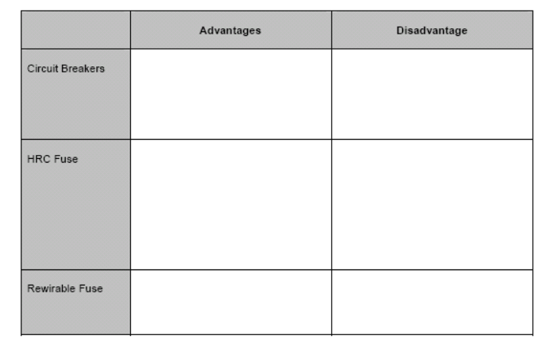

19 Complete the following table by determining the missing information and then inserting it in each empty cell.

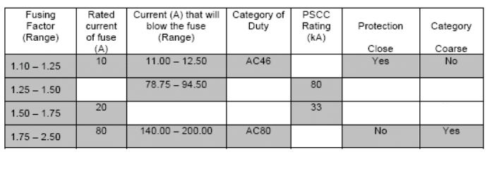

20 State the purpose of a phase failure relay.