Supply Systems - Possible Questions

- List TWO advantages, other than cost, that a three phase system has over a single phase supply system. (N99)

- Why is it desirable to balance single phase subcircuits in a three phase installation?

- Three resistive loads of 10kW, 15kW and 25kW are star connected to a 400V, three phase supply.

a) Calculate the current in each line.
b) Determine the current in the neutral.
c) Calculate the total power supplied.
d) Briefly describe what would occur to the phase voltages across the load resistors (calculations not required) if the neutral became disconnected.(J99)

- Sketch and label a diagram to show how a three phase, 400 V distribution switchboard in an engineering
workshop can be supplied from an RCD on an MEN main switchboard.
Include the following in your diagram:
• MEN switchboard, including mains in, mains earth, N and E bars, main switch, circuit protection
(fuses) and an RCD (block only)
• Cable supplying the distribution switchboard, including the number of cores.
• Distribution switchboard, including N and E bars, main switch, subcircuit protection(fuses) and subcircuit wiring to a single phase and a three phase circuit. (N00)

- List TWO types of prime movers used to drive alternators.

6 State ONE technical reason for earthing the neutral in the MEN system of supply.

7 The figure below shows a standard MEN, two phase, 400/230V, low voltage supply to a rural property in New Zealand with four typical loads shown connected and turned on. R1 is a 1kW heater, R2 is an electric jug, R3 is a bathroom heat lamp (2 lamps) and R4 is the grill element in the oven. Point X represents an open circuit that suddenly occurs when the link joining two sections of the neutral busbar falls out.
a) Calculate the current that will flow through R3 and R4.
b) Calculate the voltage that will be dropped across R3 and describe its likely effect on this particular appliance.
c) Calculate the voltage that will appear across R4, and describe its likely effect on this particular appliance. N02)

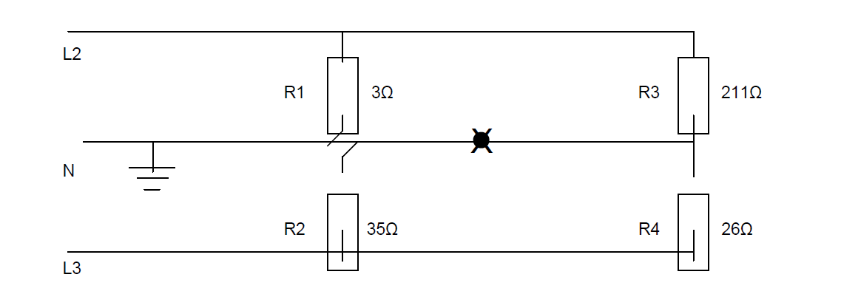

8 List TWO types of earth electrode that may be used to connect the MEN system to the mass of the earth.
(J03)

With reference to a single phase MEN system, briefly explain what is meant by the term, standard low
voltage.

- Explain what is meant by a Multiple Earthed Neutral System.

10 (a) Sketch and label a simple diagram to represent an MEN distribution system showing. (ET21)
• A delta-star-connected 11 kV/400 V supply transformer including output lines
• A single-phase consumer including main switch, and neutral and earth bar connections
• A three-phase consumer including main switch, and neutral and earth bar connections
• All earthing arrangements.
(b) State TWO reasons why an MEN system is used in New Zealand.

(c) State TWO main differences between an MEN switchboard and a distribution switchboard?

(d) What type of switchboard must be the first switchboard (closest to the point of supply) in an MEN electrical
installation ?

12. (a) Draw and label a diagram to represent the supply arrangements for an MEN distribution system
that includes: (ET26)
• A delta-star-connected 11 kV/400 V supply transformer showing the neutral and earthing arrangements
The conductors supplying a single-phase consumer installation and a three phase consumer installation
• The single-phase consumer switchboard that shows the main switch, neutral and earthing arrangements
• The three-phase consumer switchboard that shows the main switch, neutral and earthing arrangements
Fuse protection for each installation
12 (b) State TWO reasons why the neutral conductor is earthed in an MEN system

(c) State TWO factors that limit the prospective short-circuit current in an electrical installation.

(d) Describe FOUR electrical hazards that may occur in a low voltage
installation if the impedance of the main neutral is higher than the
impedance of main earth.

13. (a) A small 400V, three-phase, 4-wire commercial installation has the following resistive loads on each
phase:- (ET28)
• Red 30kW
• White 20kW
• Blue 10kW
(i) Calculate the line current in each of the three phases.

(ii) Calculate the total power of the installation

(iii) Determine the neutral current by resolution of vectors

(b) State ONE technical reason why it is important to balance the load across
the three phases of the installation?

14. (a) This diagram represents a single phase domestic installation. The current in the phase is 20A, the
neutral 10A and the main earth is 10A.

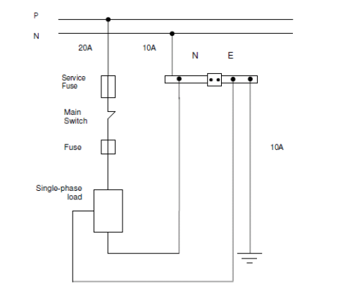

- Give TWO reasons why the neutral and earth of the installation carry the same current?
- Explain why the main earth in the installation is effective.

(b) State THREE main features that distinguish an MEN switchboard from a distribution switchboard?

(c) State TWO factors that limit the prospective short-circuit current in an electrical installation.

(d) In the New Zealand low voltage MEN distribution system the neutral is earthed. State TWO points on the
MEN distribution system where the neutral is earthed.

