Testing, Inspection and Verification - Possible Questions

1 What is meant by the term 'Testing' as applied to electrical work?

2 When using a suitable test instrument to check for isolation of a circuit the prove test prove procedures is
recommended.
What are the three checks that the procedure is intended to verify?

3 Briefly explain why, when required to carry out an insulation resistance test on the internal wiring of a
single phase electrical appliance, an ohmmeter or a multimeter should not be used.

4
i) List the four tests/checks required to ensure electrical safety when a fixed wired, three- phase, 400V
water pump and sub-circuit wiring have been installed. (Nov 99)

ii) Describe in detail how each of the tests/checks in (a) should be carried out. Include in your answer,
where applicable, the type of meter used and any minimum or maximum values that may apply

5 A single phase, 230V, 50 Hz, 6 kW, deep fryer has been repaired by you. The fryer has mineral-insulated,
metal sheathed elements and is connected to the supply by a 30A flexible cord and three pin plug. List the
four test/checks that are required to ensure electrical safety before the fryer is returned to service. (11/00)

- Describe in detail how each of the tests/checks in (a) should be carried out. Include in your answer,
where applicable, the type of meter used and any minimum or maximum values that may apply

6 A three phase socket outlet including sub-circuit wiring and switchboard work has been installed in a
bakery to supply a food mixer. (Jun 2001)
a) Which Standard should the testing of this installation comply with to ensure electrical safety?

b) List the four tests/checks required to ensure that the installation is electrically safe.

7 With respect to the electrical testing of an installation:
a) Give two reasons why polarity testing is carried out.

b) Between which conductors are insulation resistance tests to be made?

c) State the minimum allowable value of insulation resistance for an installation.

d) With respect to the earthing lead and any exposed metal in the installation, described the two main
conditions that earth continuity testing is carried out to prove.

e) What is the maximum allowable value of resistance when carrying out an earth continuity test on a
fixed wired appliance?

f) State the maximum allowable resistance between bonded exposed metal and the earth electrode?

g) State the minimum test voltage for an insulation resistance test to be carried out on a circuit that has
a voltage up to 250v ac between phase and earth.

h) State the reason why some electrical fittings, such as light dimmers, carry a warning against insulation resistance testing between phase and neutral. (N99)
8 a) (i) State ONE reason for carrying out an earth fault loop impedance test on a single-phase socket
outlet circuit.

(ii) Describe how the earth fault loop impedance tester is connected

(b) (i) State the reason for carrying out an RCD test on a single-phase portable RCD.

(ii) Describe how the RCD tester is connected.

9. Carefully read the entire question before answering parts (a) and (b). (ET21)
You have been requested to commission a new single-phase electric hot water cylinder in a small factory.
The cylinder element is an MIMS type. The connection is to be made via a new flexible cord. The cylinder
circuit is supplied by an HRC fuse on a three-phase switchboard and a lockable isolating switch is located
adjacent to the cylinder. The cylinder connects directly via a flexible cord to the isolating switch. Another
electrician has disconnected the old cylinder from the isolating switch. The isolating switch is not locked nor
is it tagged.
(a) Describe the TWO tests you will make using test instruments to ensure that the new cylinder is safe to
connect to the power supply. The tests are to be carried out after you have connected the flexible cord
to the cylinder, but before you connect it to the isolating switch. Include in your description for each test:
• The type of instrument used
• The test voltage applied - if applicable.
• The expected test result
• Whether the test result is a minimum or maximum value
Test 1

Test 2

(b) Describe the steps that you will take to ensure your own safety prior to connecting the new cylinder to the
isolating switch.

10. A 20A MCB protects a circuit consisting of multiple plug sockets supplying various electrical appliances in an office. The MCB has tripped. When the MCB is reset, it trips again when the supply is restored to the circuit. You have established that the MCB is not faulty and is correctly rated for the circuit. (ET21)
(a) State the THREE possible causes of the MCB tripping for the second time.
(b) For each of the possible causes you have stated in (a), state:
• What action you would take to establish that this is the cause.
• The action you would take to fix the problem.

- Possible cause No. 1

Action taken to establish that this is the cause.

Remedial action taken or recommended

- Possible cause No. 2

Action taken to establish that this is the cause.

Remedial action taken or recommended

- Possible cause No. 3

Action taken to establish that this is the cause.

Remedial action taken or recommended

11. (a) The figure below represents a new low voltage single-phase supply to a domestic installation. The
installation is live. (ET24)

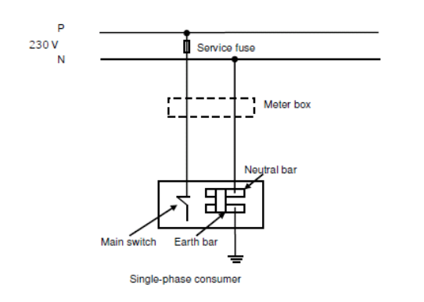

State THREE hazards that will occur if the phase and neutral are transposed.

(b) From the figure in (a) above:
(i) Describe how you would carry out an instrument test to establish whether a phase/neutral transposition has
taken place. Include in your description the type of instrument and equipment used.
(ii) State the expected instrument readings when a transposition has taken place.
(c) An existing low voltage single phase electrical installation has been operating satisfactorily for the 10 years since it was new. No electrical work has been carried out on the installation or on the surrounding distribution network since the house was built. The occupants have begun to receive electric shocks off their washing machine you have been called to investigate and make repairs for some No transposition has occurred to the mains of the house.
State TWO likely causes of the problem.
12. (a) The figure below represents an earth fault loop impedance test on a single phase socket outlet in a low voltage electrical installation. Commencing at the earth fault loop impedance tester, describe the circuit that is being tested by the tester.
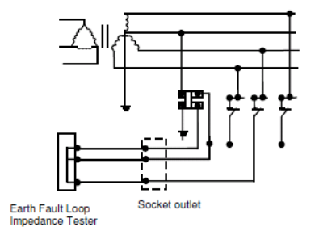

The elements of the fault loop being tested are:

(b) State TWO uses for the information gained from an earth fault loop impedance test carried out in (a) above.

(c) Why is the earth fault loop path between the earth and neutral bars and MEN link and the star point via the
main neutral considered more important than the path between the earth and neutral bars and MEN link and the
star point via the mass of earth

