Garage door controller notes
State based diagrams focus on how the system behaves and what is required to change its behaviour
Conveyance system control exemplar
Proposed diagram of activities using block logic (set-reset method)
Written description of problem –
Left button (I1) moves conveyor left transitioning to move left state and triggering LED1 (Q1) – moving the system to move left state
If in move left state and the NC stop is pressed (I3) we move back to idle state or if left prox (I4) is pressed we move back to idle state,
Actions associated with being in move left state are the timer starts in move left state and LED 1 (Q1) is on.
Right button (I2) moves conveyor right transition to move right state and triggering LED2 (Q2) – moving the system into move right state
If in move right state and NC stop button is pressed (I3) we move back to idle state or if right prox (I5) is pressed we move back to idle state
Actions associated with being in move right state are the timer starts in move right state and LED 2 (Q2) is on
If the timer reaches 10s then we move to alarm state, in alarm state, LED3 (Q3) is on and LED1 (Q1) and LED2 (Q2) are off. If left button (I1) or right button (I2) are pressed in alarm state then we move back to idle state (resetting the system).
2) State diagram representation of the problem
Right button pressed (I2=true) AND left button not pressed (I1=false) AND LED3 off (Q3=false) AND LED1 off (Q1=false)
Left button pressed (I1=true) AND right button not pressed (I2=false) AND LED3 off (Q3=false) AND LED2 off (Q2=false)
Timer=10s
Idle state all LEDs off

NC stop pressed (I3=false) OR left prox true (I4=true)
NC stop pressed (I3=false) OR right prox true (I5=true)
Move left state LED1 on (Q1=true), start timer
Move right state LED 2 on (Q2=true), start timer

Left button pressed (I1=true) OR right button pressed (I2=true)

Alarm state
LED3 on (Q3=true), LED1 off (Q1=false), LED2 off (Q2=false)
Timer=10s

3) Start by selecting the correct module
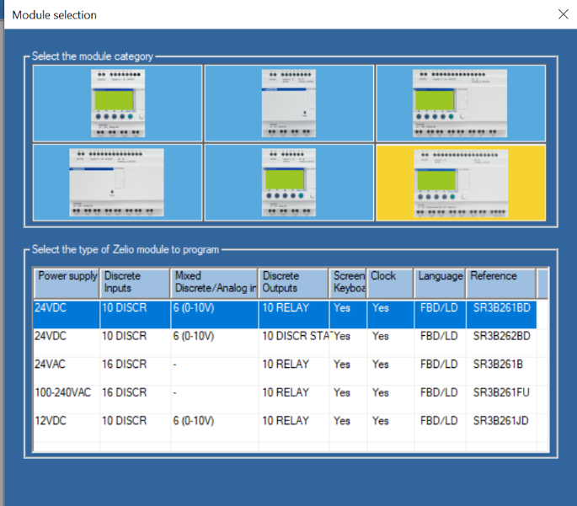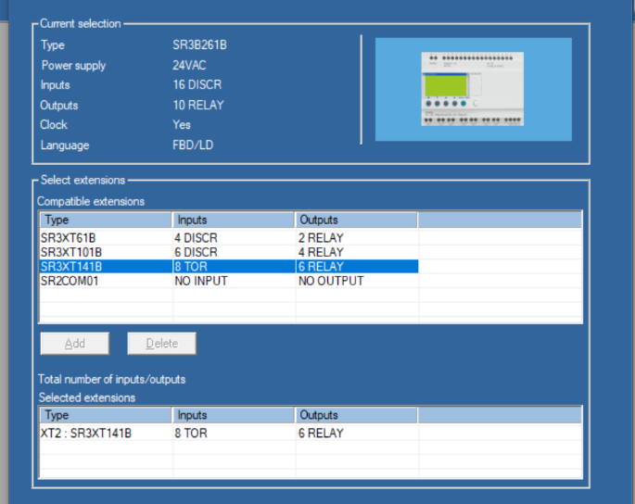
4) Develop the ladder program by locking on states if transitions go true to enter a state and resetting the state output when transitions go true to exit a state. Be sure to add an interlock if it appears that two state transition conditions could go true at the same time.
Exemplar solution in ladder logic
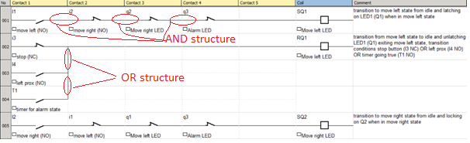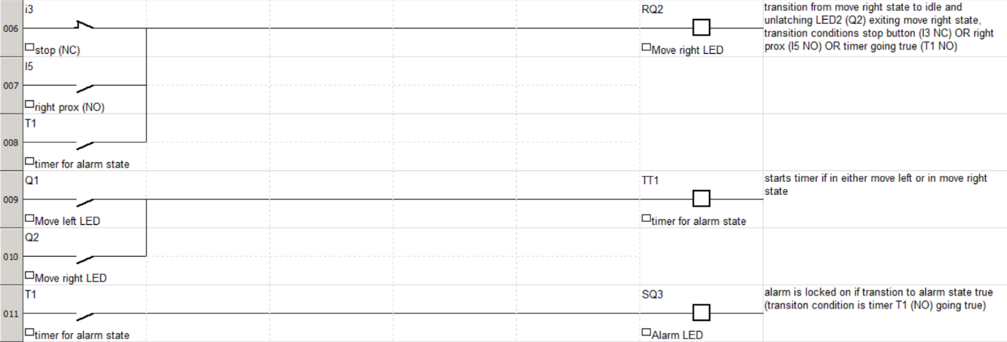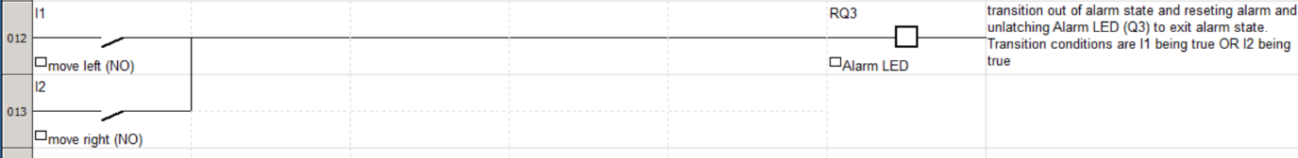
Using this method note the NC stop is represented as a NC contactor (I3) in rungs 2, 6 for the transitions back to idle however the NO left proximity sensor (I4) and the NO right proximity sensor (I5) are represented as NO contactors in rungs 3, 7 for the transitions back to idle.

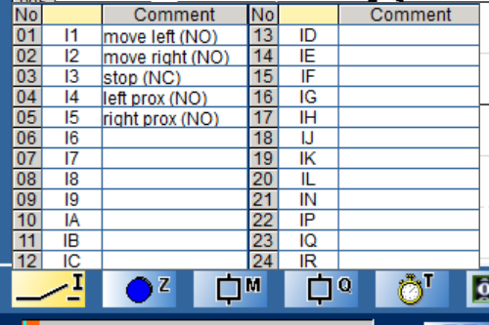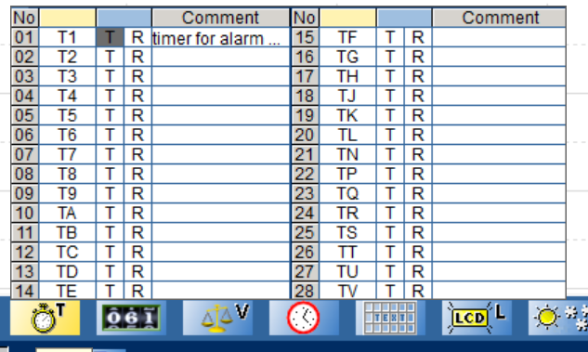
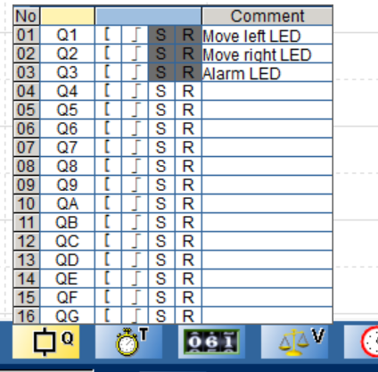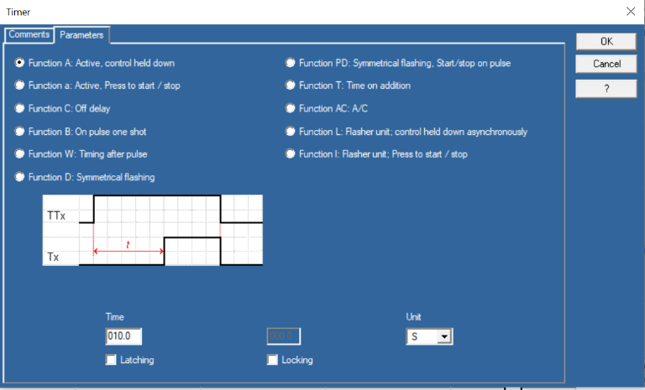
The garage door example
Proposed state diagram (notice the similarities to the state diagram for the conveyance system…. as this is a common problem)
Down button pressed (I4=true) AND up button not pressed (I1=false) AND up LED off (QB=false) AND alarm buzzer off (QG=false)
Up button pressed (I1=true) AND down button not pressed (I4=false) AND down LED off (QD=false) AND alarm buzzer off (QG=false)
Timer=20s
Idle state
all LEDs/buzzers off

NC stop pressed (IA=false) OR top limit true (I3=true)
Move down state Down LED on (QD=true), Motor on (QF=true), start the 20s timer
NC stop pressed (IA=false) OR bottom limit true (I2=true)
Move up state Up LED on (QB=true), Motor on (QF=true), start the 20s timer

up pressed (I1=true) OR down pressed (I4=true)

Alarm buzzer state
Alarm buzzer on (QG=true), up LED off (QB=false), down LED off (QD=false)
Timer=20s

