EDUC6006 Assignment Two Support Guidelines

Task
Report
Consider both scenarios below, or select one and describe one ethical dilemma you have observed in an early childhood setting. Suggest what an ethical early childhood kaiako should do: honour the wishes of the family/whānau, or continue with their centre practice as normal? Consider how your ethical decision-making could be justified by Our Code Our Standards and relevant policies and literature that support the rights of tamariki.

Scenario 1
“My son needs to eat his veggies first!”
Deepak is a 3 year old boy who has just started his journey in an early childhood setting. He is very used to home meals and it seems to be an area of particular attention for his parents. During lunchtime, the team of kaiako noticed that Deepak tends to eat his crackers and dessert biscuits first and leaves his salad and accurately cut up vegetables untouched in a small container. One Kaiako gently asks why he wouldn’t eat the salad, however Deepak seems shy and ignores the question. At the end of his first week in this ECE centre, during busy morning drop-off time, Deepak’s father asks one of the Kaiako to have a quick chat. During korero, he expresses their family’s disappointment with the untouched salad container that is persistently present in Deepak’s lunchbox. The father adds that as professional Kaiako, “You should know that eating veggies is so important for the young children!” and leaves, with visible signs of frustration.
Scenario 2
“Don’t let my daughter play boys’ games!”
Maya is a 4 year old girl who has a new friend in a group of children in a busy early childhood setting. His name is Ahmed, he is also 4 year old and he has just joined the centre’s whānau and seems to be very attached to his first friend. Ahmed adores the outdoor area, particularly the sandpit where he plays with trucks and diggers, builds new roads and sets up his own construction rules. Maya, who has never experienced this ‘boy’s stuff’, is fascinated to be the only one Ahmed allows to join in the busy construction process. After a couple of weeks, Maya’s parents ask to have a korero with the leading Kaiako and note that they haven’t been very happy to find out about ‘that new friend of Maya’. After meeting him, she has only been sharing her amazing building adventures, new knowledge about diggers and trucks and, no surprise, has come home with dirty clothes after time spent playing with sand and water. Maya’s parents would prefer her to ‘have more girls in her circle’ and are surprised kaiako have not been directing their daughter to ‘proper girls’ games’.

Word count
1500 words

What does ‘report’ mean?
Your report needs to include clear and succinct subheadings. Including ‘Introduction’ and ‘Conclusion’ is a good idea (please keep those short and to the point: this report aims to discuss…)

Suggested subheadings (variations welcome!)

Introduction (clearly state which scenarios you are refrrring to. If choosing one of your own – do not include description here please)

Selected scenarios
If including your own ethical dilemma, please describe it here. If not – This report considers two scenarios provided.

Scenario One
Copy the scenario here (this will NOT be part of the word count) or describe your own one. Ensure you are talking about a dilemma, not a conflict or a typical issue in an ECE centre.

Possible solutions for Scenario One
Describe realistic solutions that are fair, ethical and socially just for all stakeholders (“possible solution for this ethical dilemma could be…)
Justify your solutions by using:
- Our Code Our Standards (Education Council, 2017)
- Te Whāriki (Ministry of Education, 2017)
- The UNCROC (United Nations, 1989)
- Children’s Act 2014 (The New Zealand Government, 2021)
- Any relevant literature that supports children’s rights (examples: Te One (2011) – see Week 5 Moodle page; Holzcheiter et al 2019 – see week 5 Moodle page; Children, rights and powers 2019 – see in Week 10 Moodle page). If relevant to your scenario, you are also encouraged to use Tātaiako and Tāpasā resources – both are in Week 5 Moodle page). There is also a great online resource on children’s rights in the library:
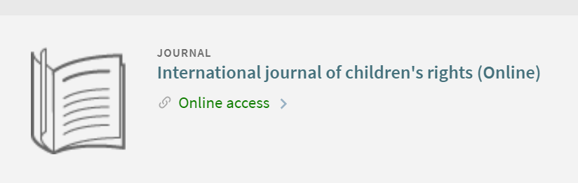

Scenario Two
Repeat the process above.

Conclusion
Succinct statement of what has been discussed in your mahi.

General notes:
- Do not copy the task
- Word count does not include scenarios
- Please carefully go through your Assignment One feedback: improvements expected in tour A2. In case there are referencing comments, please refer to APA Quick Guide uploaded in Week 10.
- In your justification, ensure there is a balance between references and your own voice
- Proofread (!) for spelling, macrons, grammar and correct referencing before submission.

Best of luck with your mahi!

