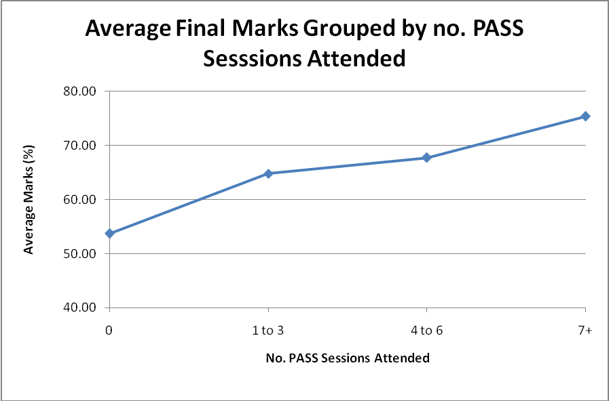
No. PASS Sessions Attended | Average Final Marks
0 | 54
1-3 | 65
4-6 | 68
7+ | 75

